RESULTADOS DEL UNIT COMMITMENT — SISTEMA IEEE 24 BARRAS
Tablas y figuras generadas desde los resultados del modelo

Unit Commitment tradicional (sistema IEEE 24 barras)
Hora | G1 | G2 | G3 | G4 | G5 | G6 | G7 | G8 | G9 | G10 | G11 | G12 | Capacidad Comprometida Total
1 |  |  |  |  |  |  | X | X | X | X | X | X | 1915
2 |  |  |  |  |  |  | X | X | X | X | X | X | 1915
3 |  |  |  |  |  |  | X | X | X | X | X | X | 1915
4 |  |  |  |  |  |  | X | X | X | X | X | X | 1915
5 |  |  |  |  |  |  | X | X | X | X | X | X | 1915
6 |  |  |  |  |  |  | X | X | X | X | X | X | 1915
7 |  |  |  |  |  | X | X | X | X | X | X | X | 2070
8 | X | X |  |  |  | X | X | X | X | X | X | X | 2374
9 | X | X | X |  |  | X | X | X | X | X | X | X | 2724
10 | X | X | X |  |  | X | X | X | X | X | X | X | 2724
11 | X | X | X |  |  | X | X | X | X | X | X | X | 2724
12 | X | X | X |  |  | X | X | X | X | X | X | X | 2724
13 | X | X | X |  |  | X | X | X | X | X | X | X | 2724
14 | X | X | X |  |  | X | X | X | X | X | X | X | 2724
15 | X | X | X |  |  | X | X | X | X | X | X | X | 2724
16 | X | X | X |  |  | X | X | X | X | X | X | X | 2724
17 | X | X | X |  |  | X | X | X | X | X | X | X | 2724
18 | X | X | X |  |  | X | X | X | X | X | X | X | 2724
19 | X | X | X |  |  | X | X | X | X | X | X | X | 2724
20 | X | X | X |  |  | X | X | X | X | X | X | X | 2724
21 | X | X | X |  |  | X | X | X | X | X | X | X | 2724
22 |  | X |  |  |  | X | X | X | X | X | X | X | 2222
23 |  |  |  |  |  | X | X | X | X | X | X | X | 2070
24 |  |  |  |  |  | X | X | X | X | X | X |  | 1720
Tabla 17. Resultados de UC del sistema IEEE 24 Barras tradicional.
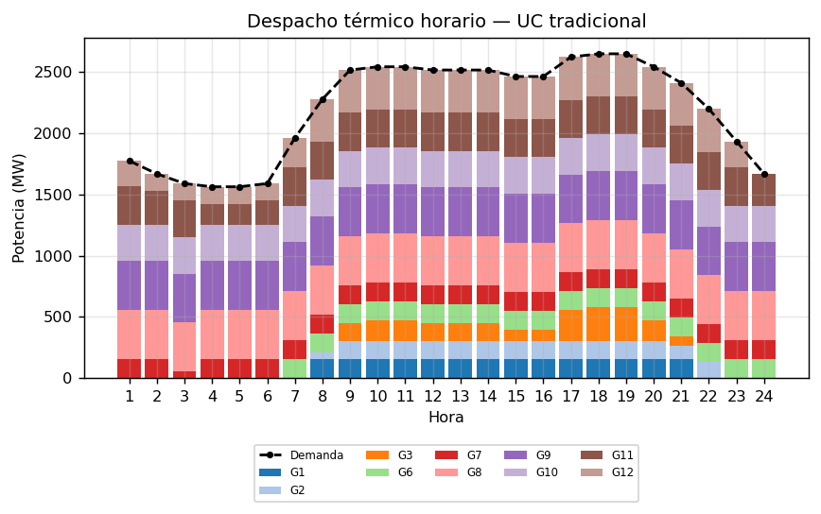
Figura 13. Despacho térmico horario en el problema de UC de manera tradicional.
Hora | Línea más cargada | Flujo (MW) | Límite (MW) | Carga (%)
1 | 16-17 | -378.1 | 500 | 75.6
2 | 16-17 | -388.8 | 500 | 77.8
3 | 16-17 | -398.4 | 500 | 79.7
4 | 16-17 | -399.4 | 500 | 79.9
5 | 16-17 | -399.4 | 500 | 79.9
6 | 16-17 | -396.8 | 500 | 79.3
7 | 14-16 | -393.1 | 500 | 78.6
8 | 14-16 | -383.4 | 500 | 76.7
9 | 14-16 | -358.3 | 500 | 71.7
10 | 14-16 | -355.1 | 500 | 71.0
11 | 14-16 | -355.1 | 500 | 71.0
12 | 14-16 | -358.3 | 500 | 71.7
13 | 14-16 | -358.3 | 500 | 71.7
14 | 14-16 | -358.3 | 500 | 71.7
15 | 14-16 | -364.5 | 500 | 72.9
16 | 14-16 | -364.5 | 500 | 72.9
17 | 14-16 | -345.8 | 500 | 69.2
18 | 14-16 | -342.7 | 500 | 68.5
19 | 14-16 | -342.7 | 500 | 68.5
20 | 14-16 | -355.1 | 500 | 71.0
21 | 14-16 | -369.6 | 500 | 73.9
22 | 14-16 | -389.7 | 500 | 77.9
23 | 14-16 | -391.2 | 500 | 78.2
24 | 16-17 | -413.9 | 500 | 82.8
Tabla 18. Flujos máximos de hora — sistema tradicional.
Componente | Descripción | Valor (USD) | % del total
Cgen | Costo variable de generación térmica | 423,951.22 | 97.66
Cfijo | Costo fijo de unidades comprometidas | 2,013.00 | 0.46
Carr | Costo de arranque de unidades | 8,131.80 | 1.87
Cvert | Penalización por vertimiento eólico | N/A | —
CSOC | Penalización por SOC bajo del BESS | N/A | —
CBESS | Operación y degradación del BESS | N/A | —
Total | Costo total de operación | 434,096.02 | 100.00
Tabla 19. Desglose de función objetivo — sistema tradicional.
Indicador | Valor
Variables continuas | 864
Variables binarias | 576
Variables totales | 1,440
Restricciones | 3,096
Estado de la solución | OPTIMAL
Brecha de optimalidad (gap) | 0.0020 %
Valor objetivo óptimo (USD) | 434,096.02
Tabla 20. Dimensión del modelo y estado de solución — sistema tradicional.

UC considerando variabilidad de generación eólica pronosticada
Hora | G1 | G2 | G3 | G4 | G5 | G6 | G7 | G8 | G9 | G10 | G11 | G12 | Eólico | Capacidad Comprometida Total
1 |  |  |  |  |  |  | X | X | X | X | X | X | 30.0 | 1,945.0
2 |  |  |  |  |  |  | X | X | X | X | X | X | 30.0 | 1,945.0
3 |  |  |  |  |  |  | X | X | X | X | X | X | 30.0 | 1,945.0
4 |  |  |  |  |  |  | X | X | X | X | X | X | 30.0 | 1,945.0
5 |  |  |  |  |  |  | X | X | X | X | X | X | 30.0 | 1,945.0
6 |  |  |  |  |  |  | X | X | X | X | X | X | 30.0 | 1,945.0
7 |  |  |  |  |  | X | X | X | X | X | X | X | 28.3 | 2,098.3
8 | X | X |  |  |  | X | X | X | X | X | X | X | 29.6 | 2,403.6
9 | X | X | X |  |  | X | X | X | X | X | X | X | 18.7 | 2,742.7
10 | X | X | X |  |  | X | X | X | X | X | X | X | 30.0 | 2,754.0
11 | X | X | X |  |  | X | X | X | X | X | X | X | 28.8 | 2,752.8
12 | X | X | X |  |  | X | X | X | X | X | X | X | 11.1 | 2,735.1
13 | X | X | X |  |  | X | X | X | X | X | X | X | 0.0 | 2,724.0
14 | X | X | X |  |  | X | X | X | X | X | X | X | 1.0 | 2,725.0
15 | X | X | X |  |  | X | X | X | X | X | X | X | 1.9 | 2,725.9
16 | X | X | X |  |  | X | X | X | X | X | X | X | 2.7 | 2,726.7
17 | X | X | X |  |  | X | X | X | X | X | X | X | 4.4 | 2,728.4
18 | X | X | X |  |  | X | X | X | X | X | X | X | 3.8 | 2,727.8
19 | X | X | X |  |  | X | X | X | X | X | X | X | 1.3 | 2,725.3
20 | X | X | X |  |  | X | X | X | X | X | X | X | 1.3 | 2,725.3
21 | X | X | X |  |  | X | X | X | X | X | X | X | 10.9 | 2,734.9
22 | X |  |  |  |  | X | X | X | X | X | X | X | 6.6 | 2,228.6
23 |  |  |  |  |  | X | X | X | X | X | X | X | 1.6 | 2,071.6
24 |  |  |  |  |  | X | X | X | X | X | X |  | 2.4 | 1,722.4
Tabla 21. Resultados de UC considerando variabilidad de generación eólica pronosticada.
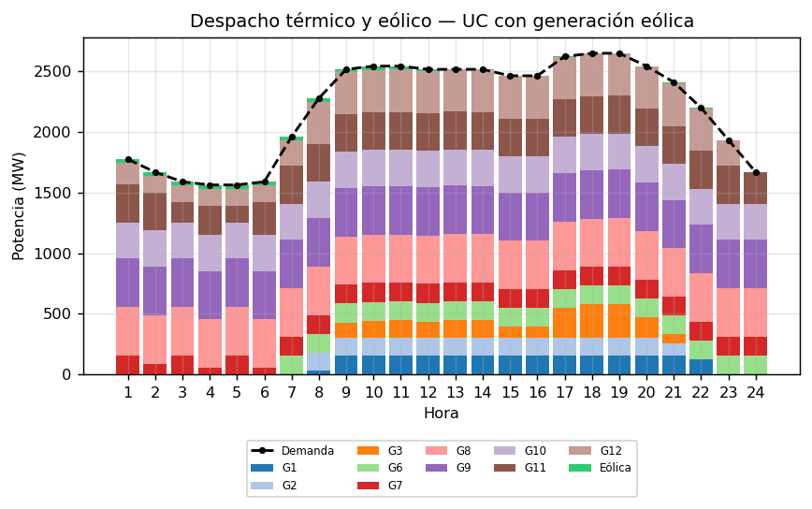
Figura 14. Despacho térmico y de energía eólica por horario considerando generación eólica pronosticada.
Hora | Disponible (MW) | Utilizada (MW) | Vertimiento (MW)
1 | 30.0 | 30.0 | 0.0
2 | 30.0 | 30.0 | 0.0
3 | 30.0 | 30.0 | 0.0
4 | 30.0 | 30.0 | 0.0
5 | 30.0 | 30.0 | 0.0
6 | 30.0 | 30.0 | 0.0
7 | 28.3 | 28.3 | 0.0
8 | 29.6 | 29.6 | 0.0
9 | 18.7 | 18.7 | 0.0
10 | 30.0 | 30.0 | 0.0
11 | 28.8 | 28.8 | 0.0
12 | 11.1 | 11.1 | 0.0
13 | 0.0 | 0.0 | 0.0
14 | 1.0 | 1.0 | 0.0
15 | 1.9 | 1.9 | 0.0
16 | 2.7 | 2.7 | 0.0
17 | 4.4 | 4.4 | 0.0
18 | 3.8 | 3.8 | 0.0
19 | 1.3 | 1.3 | 0.0
20 | 1.3 | 1.3 | 0.0
21 | 10.9 | 10.9 | 0.0
22 | 6.6 | 6.6 | 0.0
23 | 1.6 | 1.6 | 0.0
24 | 2.4 | 2.4 | 0.0
Tabla 22. Generación eólica disponible, utilizada y vertimiento — con generación eólica pronosticada.
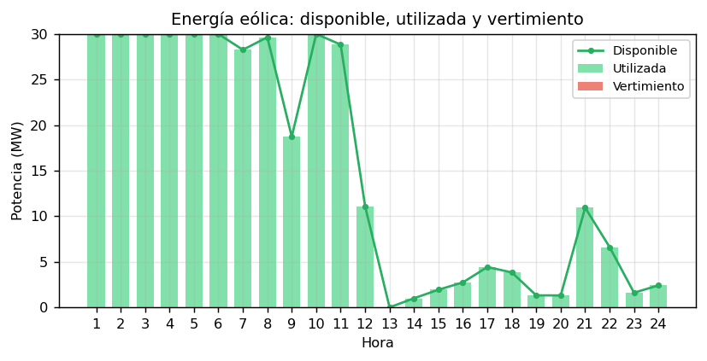
Figura 15. Energía eólica disponible frente a la utilizada — con generación eólica pronosticada.
Hora | Línea más cargada | Flujo (MW) | Límite (MW) | Carga (%)
1 | 16-17 | -379.3 | 500 | 75.9
2 | 16-17 | -391.0 | 500 | 78.2
3 | 16-17 | -398.0 | 500 | 79.6
4 | 16-17 | -402.3 | 500 | 80.5
5 | 16-17 | -400.6 | 500 | 80.1
6 | 16-17 | -399.6 | 500 | 79.9
7 | 14-16 | -388.7 | 500 | 77.8
8 | 14-16 | -383.1 | 500 | 76.6
9 | 14-16 | -358.9 | 500 | 71.8
10 | 14-16 | -356.2 | 500 | 71.2
11 | 14-16 | -356.1 | 500 | 71.2
12 | 14-16 | -358.7 | 500 | 71.7
13 | 14-16 | -358.3 | 500 | 71.7
14 | 14-16 | -358.3 | 500 | 71.7
15 | 14-16 | -364.6 | 500 | 72.9
16 | 14-16 | -364.6 | 500 | 72.9
17 | 14-16 | -345.9 | 500 | 69.2
18 | 14-16 | -342.8 | 500 | 68.6
19 | 14-16 | -342.7 | 500 | 68.5
20 | 14-16 | -355.2 | 500 | 71.0
21 | 14-16 | -369.6 | 500 | 73.9
22 | 14-16 | -390.2 | 500 | 78.0
23 | 14-16 | -391.0 | 500 | 78.2
24 | 16-17 | -414.0 | 500 | 82.8
Tabla 23. Flujos máximos de hora — considerando generación eólica pronosticada.
Componente | Descripción | Valor (USD) | % del total
Cgen | Costo variable de generación térmica | 418,889.67 | 97.64
Cfijo | Costo fijo de unidades comprometidas | 2,013.00 | 0.47
Carr | Costo de arranque de unidades | 8,131.80 | 1.90
Cvert | Penalización por vertimiento eólico | 0.00 | 0.00
CSOC | Penalización por SOC bajo del BESS | N/A | —
CBESS | Operación y degradación del BESS | N/A | —
Total | Costo total de operación | 429,034.47 | 100.00
Tabla 24. Desglose de función objetivo — considerando generación eólica pronosticada.
Indicador | Valor
Variables continuas | 888
Variables binarias | 576
Variables totales | 1,464
Restricciones | 3,096
Estado de la solución | OPTIMAL
Brecha de optimalidad (gap) | 0.0004 %
Valor objetivo óptimo (USD) | 429,034.47
Tabla 25. Dimensión del modelo y estado de solución — considerando generación eólica pronosticada.

UC considerando recursos de flexibilidad (BESS)
Hora | G1 | G2 | G3 | G4 | G5 | G6 | G7 | G8 | G9 | G10 | G11 | G12 | BESS | Capacidad Comprometida Total
1 |  |  |  |  |  | X |  | X | X | X | X | X | 0.0 | 1,915.0
2 |  |  |  |  |  | X |  | X | X | X | X | X | 0.0 | 1,915.0
3 |  |  |  |  |  | X |  | X | X | X | X | X | 0.0 | 1,915.0
4 |  |  |  |  |  | X |  | X | X | X | X | X | -20.0 | 1,895.0
5 |  |  |  |  |  | X |  | X | X | X | X | X | 0.0 | 1,915.0
6 |  |  |  |  |  | X |  | X | X | X | X | X | -1.1 | 1,913.9
7 |  |  |  |  |  | X | X | X | X | X | X | X | 0.0 | 2,070.0
8 | X | X |  |  |  | X | X | X | X | X | X | X | 0.0 | 2,374.0
9 | X | X | X |  |  | X | X | X | X | X | X | X | 20.0 | 2,744.0
10 | X | X | X |  |  | X | X | X | X | X | X | X | 0.0 | 2,724.0
11 | X | X | X |  |  | X | X | X | X | X | X | X | 0.0 | 2,724.0
12 | X | X | X |  |  | X | X | X | X | X | X | X | 0.0 | 2,724.0
13 | X | X | X |  |  | X | X | X | X | X | X | X | 0.0 | 2,724.0
14 | X | X | X |  |  | X | X | X | X | X | X | X | 17.0 | 2,741.0
15 | X | X | X |  |  | X | X | X | X | X | X | X | 0.0 | 2,724.0
16 | X | X | X |  |  | X | X | X | X | X | X | X | 0.0 | 2,724.0
17 | X | X | X |  |  | X | X | X | X | X | X | X | 0.0 | 2,724.0
18 | X | X | X |  |  | X | X | X | X | X | X | X | 0.0 | 2,724.0
19 | X | X | X |  |  | X | X | X | X | X | X | X | -0.0 | 2,724.0
20 | X | X | X |  |  | X | X | X | X | X | X | X | 20.0 | 2,744.0
21 | X | X | X |  |  | X | X | X | X | X | X | X | 0.0 | 2,724.0
22 | X |  |  |  |  | X | X | X | X | X | X | X | 0.0 | 2,222.0
23 |  |  |  |  |  | X | X | X | X | X | X | X | -12.1 | 2,057.9
24 |  |  |  |  |  | X | X | X | X | X | X |  | -30.0 | 1,690.0
Tabla 26. Resultados de UC del sistema IEEE 24 Barras considerando recursos flexibles.
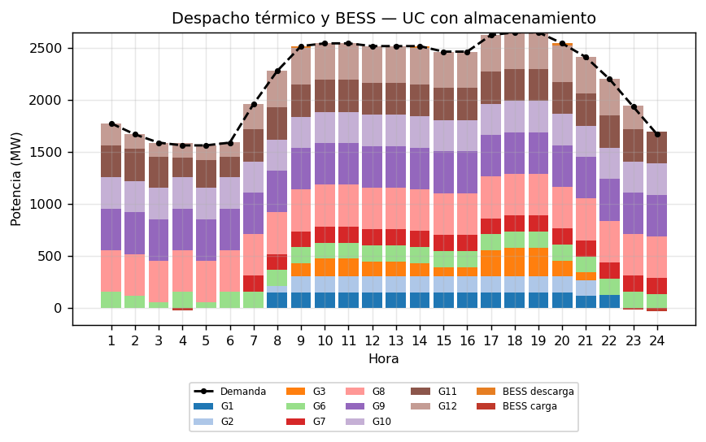
Figura 16. Despacho térmico y BESS por horario considerando almacenamiento de energía.
Hora | Carga (MW) | Descarga (MW) | SOC (%)
1 | 0.0 | 0.0 | 80.0
2 | 0.0 | 0.0 | 80.0
3 | 0.0 | 0.0 | 80.0
4 | 20.0 | 0.0 | 99.0
5 | 0.0 | 0.0 | 99.0
6 | 1.1 | 0.0 | 100.0
7 | 0.0 | 0.0 | 100.0
8 | 0.0 | 0.0 | 100.0
9 | 0.0 | 20.0 | 78.9
10 | 0.0 | 0.0 | 78.9
11 | 0.0 | 0.0 | 78.9
12 | 0.0 | 0.0 | 78.9
13 | 0.0 | 0.0 | 78.9
14 | 0.0 | 17.0 | 61.1
15 | 0.0 | 0.0 | 61.1
16 | 0.0 | 0.0 | 61.1
17 | 0.0 | 0.0 | 61.1
18 | 0.0 | 0.0 | 61.1
19 | 0.0 | -0.0 | 61.1
20 | 0.0 | 20.0 | 40.0
21 | 0.0 | 0.0 | 40.0
22 | 0.0 | 0.0 | 40.0
23 | 12.1 | 0.0 | 51.5
24 | 30.0 | 0.0 | 80.0
Tabla 27. Operación del BESS: carga, descarga y SOC — considerando recursos flexibles.
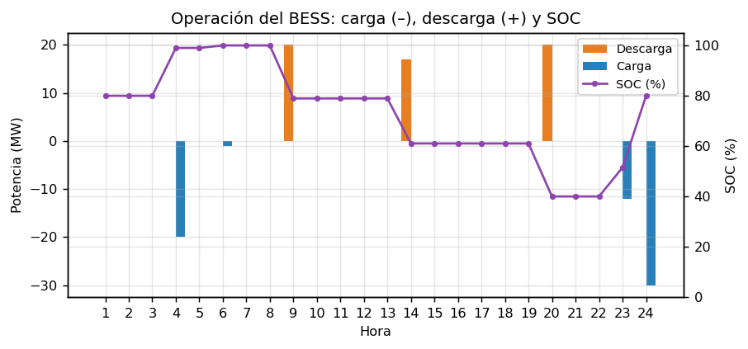
Figura 17. Potencia de carga (–) y descarga (+) del BESS y evolución del SOC — con almacenamiento.
Hora | Línea más cargada | Flujo (MW) | Límite (MW) | Carga (%)
1 | 16-17 | -405.8 | 500 | 81.2
2 | 16-17 | -410.7 | 500 | 82.1
3 | 16-17 | -408.1 | 500 | 81.6
4 | 16-17 | -426.3 | 500 | 85.3
5 | 16-17 | -410.7 | 500 | 82.2
6 | 16-17 | -424.4 | 500 | 84.9
7 | 14-16 | -393.1 | 500 | 78.6
8 | 14-16 | -383.4 | 500 | 76.7
9 | 14-16 | -359.0 | 500 | 71.8
10 | 14-16 | -355.1 | 500 | 71.0
11 | 14-16 | -355.1 | 500 | 71.0
12 | 14-16 | -358.3 | 500 | 71.7
13 | 14-16 | -358.3 | 500 | 71.7
14 | 14-16 | -358.9 | 500 | 71.8
15 | 14-16 | -364.5 | 500 | 72.9
16 | 14-16 | -364.5 | 500 | 72.9
17 | 14-16 | -345.8 | 500 | 69.2
18 | 14-16 | -342.7 | 500 | 68.5
19 | 14-16 | -342.7 | 500 | 68.5
20 | 14-16 | -355.9 | 500 | 71.2
21 | 14-16 | -369.5 | 500 | 73.9
22 | 14-16 | -390.2 | 500 | 78.0
23 | 14-16 | -393.1 | 500 | 78.6
24 | 16-17 | -409.4 | 500 | 81.9
Tabla 28. Flujos máximos de hora — considerando recursos flexibles.
Componente | Descripción | Valor (USD) | % del total
Cgen | Costo variable de generación térmica | 423,440.22 | 97.57
Cfijo | Costo fijo de unidades comprometidas | 2,013.00 | 0.46
Carr | Costo de arranque de unidades | 8,131.80 | 1.87
Cvert | Penalización por vertimiento eólico | N/A | —
CSOC | Penalización por SOC bajo del BESS | 0.00 | 0.00
CBESS | Operación y degradación del BESS | 388.97 | 0.09
Total | Costo total de operación | 433,973.99 | 100.00
Tabla 29. Desglose de función objetivo — considerando recursos flexibles.
Indicador | Valor
Variables continuas | 960
Variables binarias | 600
Variables totales | 1,560
Restricciones | 3,285
Estado de la solución | OPTIMAL
Brecha de optimalidad (gap) | 0.0020 %
Valor objetivo óptimo (USD) | 433,973.99
Tabla 30. Dimensión del modelo y estado de solución — considerando recursos flexibles.

UC considerando generación eólica pronosticada y recursos de flexibilidad
Hora | G1 | G2 | G3 | G4 | G5 | G6 | G7 | G8 | G9 | G10 | G11 | G12 | BESS | Eólico | Capacidad Comprometida Total
1 |  |  |  |  |  | X | X | X | X | X | X |  | 25.8 | 30.0 | 1,775.8
2 |  |  |  |  |  | X | X | X | X | X | X |  | 5.8 | 30.0 | 1,755.8
3 |  |  |  |  |  | X | X | X | X | X | X |  | -16.1 | 30.0 | 1,733.9
4 |  |  |  |  |  | X | X | X | X | X | X |  | 0.0 | 30.0 | 1,750.0
5 |  |  |  |  |  | X | X | X | X | X | X |  | -20.0 | 30.0 | 1,730.0
6 |  |  |  |  |  | X | X | X | X | X | X |  | -20.0 | 30.0 | 1,730.0
7 |  |  |  |  |  | X | X | X | X | X | X | X | 0.0 | 28.3 | 2,098.3
8 | X | X |  |  |  | X | X | X | X | X | X | X | 0.0 | 29.6 | 2,403.6
9 | X | X | X |  |  | X | X | X | X | X | X | X | -0.0 | 18.7 | 2,742.7
10 | X | X | X |  |  | X | X | X | X | X | X | X | 0.0 | 30.0 | 2,754.0
11 | X | X | X |  |  | X | X | X | X | X | X | X | 0.0 | 28.8 | 2,752.8
12 | X | X | X |  |  | X | X | X | X | X | X | X | -0.0 | 11.1 | 2,735.1
13 | X | X | X |  |  | X | X | X | X | X | X | X | 0.0 | 0.0 | 2,724.0
14 | X | X | X |  |  | X | X | X | X | X | X | X | 0.0 | 1.0 | 2,725.0
15 | X | X | X |  |  | X | X | X | X | X | X | X | 0.0 | 1.9 | 2,725.9
16 | X | X | X |  |  | X | X | X | X | X | X | X | 0.0 | 2.7 | 2,726.7
17 | X | X | X |  |  | X | X | X | X | X | X | X | 3.0 | 4.4 | 2,731.4
18 | X | X | X |  |  | X | X | X | X | X | X | X | 0.0 | 3.8 | 2,727.8
19 | X | X | X |  |  | X | X | X | X | X | X | X | 0.0 | 1.3 | 2,725.3
20 | X | X | X |  |  | X | X | X | X | X | X | X | 20.0 | 1.3 | 2,745.3
21 | X | X |  |  |  | X | X | X | X | X | X | X | 27.0 | 10.9 | 2,412.0
22 |  | X |  |  |  | X | X | X | X | X | X | X | 7.0 | 6.6 | 2,235.6
23 |  |  |  |  |  | X | X | X | X | X | X | X | -12.1 | 1.6 | 2,059.5
24 |  |  |  |  |  | X | X | X | X | X | X |  | -30.0 | 2.4 | 1,692.4
Tabla 31. Resultados de UC considerando variabilidad de generación eólica pronosticada y recursos flexibles.
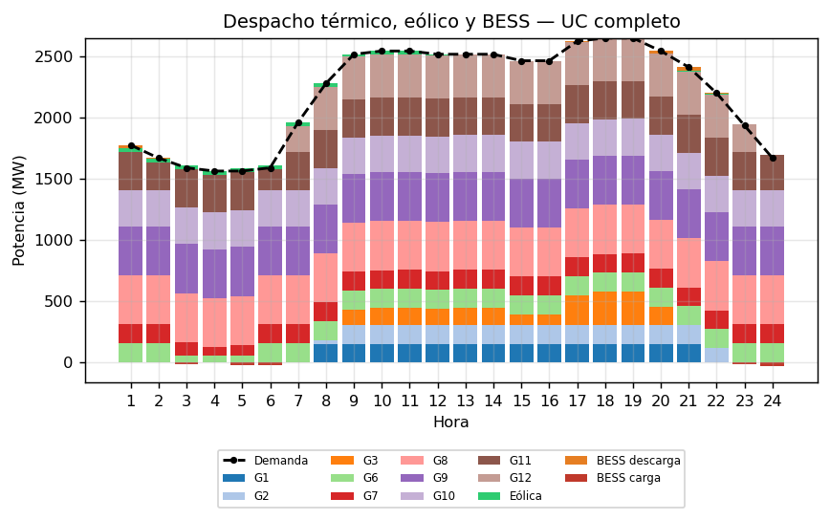
Figura 18. Despacho térmico, energía eólica y BESS por horario considerando generación eólica y almacenamiento.
Hora | Disponible (MW) | Utilizada (MW) | Vertimiento (MW)
1 | 30.0 | 30.0 | 0.0
2 | 30.0 | 30.0 | 0.0
3 | 30.0 | 30.0 | 0.0
4 | 30.0 | 30.0 | 0.0
5 | 30.0 | 30.0 | 0.0
6 | 30.0 | 30.0 | 0.0
7 | 28.3 | 28.3 | 0.0
8 | 29.6 | 29.6 | 0.0
9 | 18.7 | 18.7 | 0.0
10 | 30.0 | 30.0 | 0.0
11 | 28.8 | 28.8 | 0.0
12 | 11.1 | 11.1 | 0.0
13 | 0.0 | 0.0 | 0.0
14 | 1.0 | 1.0 | 0.0
15 | 1.9 | 1.9 | 0.0
16 | 2.7 | 2.7 | 0.0
17 | 4.4 | 4.4 | 0.0
18 | 3.8 | 3.8 | 0.0
19 | 1.3 | 1.3 | 0.0
20 | 1.3 | 1.3 | 0.0
21 | 10.9 | 10.9 | 0.0
22 | 6.6 | 6.6 | 0.0
23 | 1.6 | 1.6 | 0.0
24 | 2.4 | 2.4 | 0.0
Tabla 32. Generación eólica disponible, utilizada y vertimiento — con eólica y recursos flexibles.

Figura 19. Energía eólica disponible frente a la utilizada — con eólica y recursos flexibles.
Hora | Carga (MW) | Descarga (MW) | SOC (%)
1 | 0.0 | 25.8 | 52.8
2 | 0.0 | 5.8 | 46.7
3 | 16.1 | 0.0 | 62.0
4 | 0.0 | 0.0 | 62.0
5 | 20.0 | 0.0 | 81.0
6 | 20.0 | 0.0 | 100.0
7 | -0.0 | 0.0 | 100.0
8 | 0.0 | 0.0 | 100.0
9 | 0.0 | -0.0 | 100.0
10 | 0.0 | 0.0 | 100.0
11 | 0.0 | 0.0 | 100.0
12 | 0.0 | -0.0 | 100.0
13 | 0.0 | 0.0 | 100.0
14 | 0.0 | 0.0 | 100.0
15 | 0.0 | 0.0 | 100.0
16 | 0.0 | 0.0 | 100.0
17 | 0.0 | 3.0 | 96.9
18 | 0.0 | 0.0 | 96.9
19 | 0.0 | 0.0 | 96.9
20 | 0.0 | 20.0 | 75.8
21 | 0.0 | 27.0 | 47.4
22 | 0.0 | 7.0 | 40.0
23 | 12.1 | 0.0 | 51.5
24 | 30.0 | 0.0 | 80.0
Tabla 33. Operación del BESS: carga, descarga y SOC — con eólica y recursos flexibles.
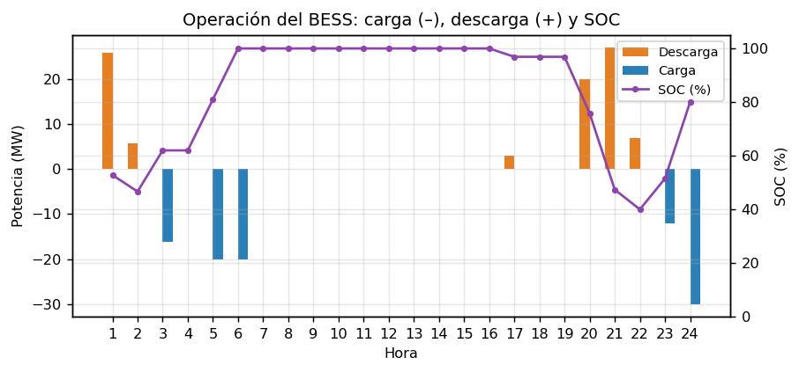
Figura 20. Potencia de carga (–) y descarga (+) del BESS y evolución del SOC — con eólica y recursos flexibles.
Hora | Línea más cargada | Flujo (MW) | Límite (MW) | Carga (%)
1 | 16-17 | -405.5 | 500 | 81.1
2 | 16-17 | -415.3 | 500 | 83.1
3 | 16-17 | -406.8 | 500 | 81.4
4 | 16-17 | -410.8 | 500 | 82.2
5 | 16-17 | -409.7 | 500 | 81.9
6 | 16-17 | -422.3 | 500 | 84.5
7 | 14-16 | -388.7 | 500 | 77.8
8 | 14-16 | -383.5 | 500 | 76.7
9 | 14-16 | -358.9 | 500 | 71.8
10 | 14-16 | -356.2 | 500 | 71.2
11 | 14-16 | -356.1 | 500 | 71.2
12 | 14-16 | -358.7 | 500 | 71.7
13 | 14-16 | -358.3 | 500 | 71.7
14 | 14-16 | -358.3 | 500 | 71.7
15 | 14-16 | -364.6 | 500 | 72.9
16 | 14-16 | -364.6 | 500 | 72.9
17 | 14-16 | -346.0 | 500 | 69.2
18 | 14-16 | -342.8 | 500 | 68.6
19 | 14-16 | -342.7 | 500 | 68.5
20 | 14-16 | -355.9 | 500 | 71.2
21 | 8-9 | -136.0 | 175 | 77.7
22 | 14-16 | -389.8 | 500 | 78.0
23 | 14-16 | -392.8 | 500 | 78.6
24 | 16-17 | -412.8 | 500 | 82.6
Tabla 34. Flujos máximos de hora — con eólica y recursos flexibles.
Componente | Descripción | Valor (USD) | % del total
Cgen | Costo variable de generación térmica | 417,786.47 | 97.49
Cfijo | Costo fijo de unidades comprometidas | 2,003.00 | 0.47
Carr | Costo de arranque de unidades | 8,131.80 | 1.90
Cvert | Penalización por vertimiento eólico | 0.00 | 0.00
CSOC | Penalización por SOC bajo del BESS | 0.00 | 0.00
CBESS | Operación y degradación del BESS | 605.09 | 0.14
Total | Costo total de operación | 428,526.36 | 100.00
Tabla 35. Desglose de función objetivo — con eólica y recursos flexibles.
Indicador | Valor
Variables continuas | 984
Variables binarias | 600
Variables totales | 1,584
Restricciones | 3,285
Estado de la solución | OPTIMAL
Brecha de optimalidad (gap) | 0.0000 %
Valor objetivo óptimo (USD) | 428,526.36
Tabla 36. Dimensión del modelo y estado de solución — con eólica y recursos flexibles.

Ubicación óptima y comparación de escenarios
# | Nodo BESS | Nodo Eólico | Costo total ($) | Sobrecosto vs. óptimo (%)
1 | 1 | 1 | 428,526.36 | 0.000 %
2 | 1 | 2 | 428,526.36 | 0.000 %
3 | 1 | 3 | 428,526.36 | 0.000 %
4 | 1 | 4 | 428,526.36 | 0.000 %
5 | 1 | 5 | 428,526.36 | 0.000 %
6 | 1 | 6 | 428,526.36 | 0.000 %
7 | 1 | 7 | 428,526.36 | 0.000 %
8 | 1 | 8 | 428,526.36 | 0.000 %
9 | 1 | 9 | 428,526.36 | 0.000 %
10 | 1 | 10 | 428,526.36 | 0.000 %
Tabla 37. Diez configuraciones de ubicación del BESS y del parque eólico con el menor costo total de operación.
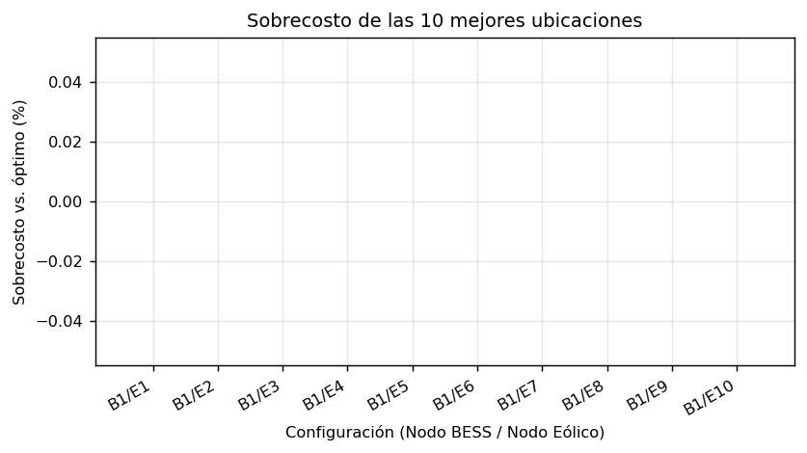
Figura 21. Mejores configuraciones de posicionamiento del BESS y la generación eólica.
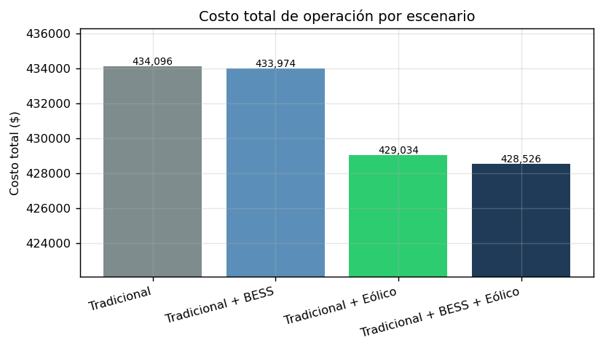
Figura 22. Comparación entre los escenarios y su costo total en la función objetivo.
Escenario | Costo Total ($) | Ahorro (%)
Tradicional | 434,096.02 | ----
Tradicional + BESS | 433,973.99 | 0.03 %
Tradicional + Eólico | 429,034.47 | 1.17 %
Tradicional + BESS + Eólico | 428,526.36 | 1.28 %
Tabla 38. Ahorro porcentual por escenario respecto del caso tradicional.

